|  |  |  |  |
| --- | --- | --- | --- |
|  | Bansilal Ramnath Agarwal Charitable Trust's  Vishwakarma Institute of Information Technology  **Department of Artificial Intelligence and Data**  **Science** | | |
| Name: Siddhesh Dilip Khairnar | | | |
| Class: SY | Division: B | | Roll No: 272028 |
| Semester: IV | | Academic Year: 2022-2023 | |
| Subject Name & Code: Fundamentals of Computer Networks: ADUA22203 | | | |
| Title of Assignment: Write a program using UDP Sockets to enable file transfer (Script, Text, Audio and Video one file each) between two machines. | | | |
| Date of Performance: 27-04-2023 | | Date of Submission: 27-04-2023 | |

# Assignment No.- 8

**Program:**

## Server.js:

import java.io.PrintWriter; import java.net.DatagramPacket; import java.net.DatagramSocket; import java.net.InetAddress;

public class Server {

public static void main(String[] args) throws Exception {

System.out.print("hello");

try (DatagramSocket s = new DatagramSocket(65535)) { InetAddress ia = InetAddress.getLocalHost();

byte[] filename = new byte[1000]; byte[] b = new byte[10000000];

// receiving name

DatagramPacket name = new DatagramPacket(filename, filename.length); s.receive(name);

System.out.print("hello"); System.out.println(new String(name.getData()));

DatagramPacket p = new DatagramPacket(b, b.length); s.receive(p);

System.out.print("hello"); System.out.println(new String(p.getData()));

String rec = "Received your packet"; byte[] b1 = rec.getBytes(); System.out.println(b1);

DatagramPacket p1 = new DatagramPacket(b1, b1.length, ia, p.getPort()); s.send(p1);

String fname = new String(name.getData()).trim();

fname = "/Users/pranavbagade/Desktop/VIIT/FCN" + fname; System.out.println(fname);

String filedata = new String(p.getData()).trim(); System.out.println(filedata);

PrintWriter pw = new PrintWriter(fname); pw.println(filedata);

pw.close();

}

}

}

## Client.js:

import java.io.BufferedReader; import java.io.File;

import java.io.FileReader;

import java.net.DatagramPacket; import java.net.DatagramSocket; import java.net.InetAddress; import java.util.Scanner;

public class Client {

public static void main(String[] args)throws Exception {

// TODO Auto-generated method stub Scanner sc=new Scanner(System.in); DatagramSocket s=new DatagramSocket(); InetAddress ia=InetAddress.getLocalHost();

File f1=new File("/Users/yashagarwal/Desktop/fcn"); File[] files=f1.listFiles();

StringBuilder sb=new StringBuilder("\n"); int x=0;

for(int i=0;i<files.length;i++)

{

if(files[i].canRead())

{

sb.append(files[i].getName()+" ,size"+files[i].length()+"bytes\n"); x++;

}

}

System.out.println(x+" Files found"); System.out.println(sb);

System.out.println(" Enter filename for download "); String fname = sc.nextLine(); System.out.println(fname);

boolean flag = false; int id= 0;

for(int i=0;i<files.length;i++)

{

if(files[i].getName().toString().equalsIgnoreCase(fname))

{ flag = true; id = i;

break;

}

}

if(!flag)

{

System.out.println(fname + " does not exist!"); return;

}

File filetocopy=new File(files[id].getAbsolutePath()); FileReader fileReader=new FileReader(filetocopy); BufferedReader br=new BufferedReader(fileReader); StringBuilder sb1=new StringBuilder();

String line; while((line=br.readLine())!=null)

{

sb1.append(line); sb1.append("\n");

}

System.out.println(sb1.toString());

byte[] sentname=files[id].getName().getBytes();

DatagramPacket p1=new DatagramPacket(sentname,sentname.length,ia,65535); s.send(p1);

byte[] senttoserver=sb1.toString().getBytes(); DatagramPacket p2=new DatagramPacket(senttoserver,senttoserver.length,ia,65535); s.send(p2);

s.close();

}

}

# Output:

**File:**

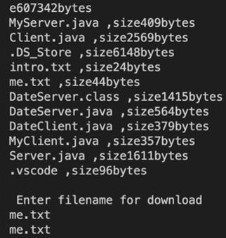

**Script:**

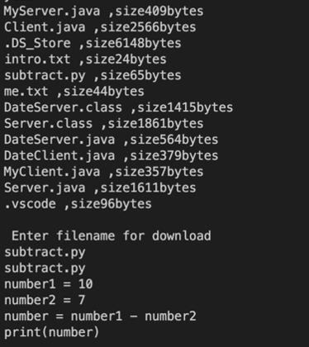

**Audio:**



